# Conflict Scenario

## **Review**

### Interpersonal Conflict Management Styles

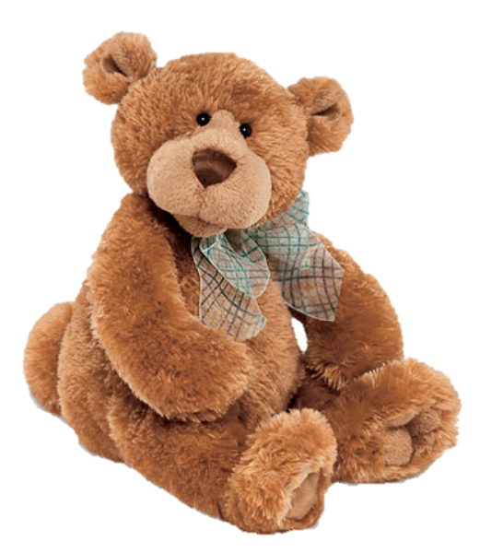

[CC 2.0 BY Matthew](https://www.flickr.com/photos/falcon1961/3304306800/)



[CC SA 3.0 Unported BY Jonathan Zander](https://en.wikipedia.org/wiki/File:Florida_Box_Turtle_Digon3.jpg)



[CC 3.0 BY Superawesomevectors](https://superawesomevectors.deviantart.com/art/Shark-Cartoon-Free-Vector-Illustration-643399222)



[CC0](https://pixabay.com/en/urban-lost-hiding-afraid-1002149/)

Low to High Concern for Other

Concern for Self



CC SA 2.0 Generic BY [Carine06 from UK](https://commons.wikimedia.org/wiki/File:Flickr_-_Carine06_-_%22I_give_up.%22.jpg)



CC 2.0 BY [Zabara Alexander](https://www.flickr.com/photos/zabara_tango/6955720271)



[CC0](https://commons.wikimedia.org/wiki/File:US_Army_53525_Soldiers_compete_in_Tae_Kwon_Do_tournament_for_Warrior_Country_level.jpg)

### **Interpersonal Conflict Resolution**

The following diagram shows a process that can be followed when trying to resolve interpersonal conflict.

### Listening

A considerable proportion of our communication involves listening, yet little attention is devoted to improving listening. HURIER is an acronym for tips that can be used to improve listening.

### “I” Phrases for Conflict Resolution

The “I” phrase is used during conflict resolutions to avoid attacking others. Open the conversation with a statement in first person, passive voice: “I feel … when … because … I would like …”

Adapted from (Dwyer 2012, p. 40)

## **Student Name and ID:** Brodie Lucht 12195968

## **Student Name and ID:** Thomas Vickery 12190332

## **Student Name and ID:** Savannah Dockerty 12192333

## **Scenario**

Find a partner. Read the scenario below. Choose one partner to be Joe Bloggs, and the other to be Jane Doe. Together, answer the following to help prepare you for the role play.

## **Scenario: Joe did not complete a task by the deadline**

Joe and Jane are working on a report that is due today. Joe was assigned the task of writing the executive summary. Unfortunately, Joe has not completed the task.

What is the most appropriate conflict management strategy for Jane to use in this situation? (Choose one)

Compete/Force

Compromise

Avoid/Withdraw

Collaborate/Confront

Accommodate/Smooth

Why did you choose the above conflict management strategy?

Highest possibility of yielding a positive outcome for both parties. Accommodating or compromising may cause further problems in the long run. While avoiding would not fix the problem of not having the report complete and competing or forcing Joe to do his part will likely result in further conflict. A collaboration between the 2 to complete the task will help the conflict have the most beneficial end for both Jane and Joe after this assignment and for other assignments in the future.

### **Listen and Understand**

How could Jane start the conversation?

Hey Joe, have you finished the executive summary? Its due today.

Describe the purpose of the discussion. Describe the conflict. What questions could Jane ask to determine Joe’s perspective of the situation?

The purpose of the discussion would be for Jane to determine how much Joe has done on his part of the assignment and to determine why he hasn’t completed it.

The conflict would likely arise in Joe’s reasoning for not having the assignment done and Jane’s urgency to get the assignment finished for the due date.

Why haven’t you completed the assignment?

Aren’t you worried, its due today?

Why didn’t you tell me earlier if you couldn’t complete it?

Can we sit down and do it now?

Write sentences that features the “I” phrase, such as in the example below:

“I feel *[your feeling]* when *[their behaviour]* because *[effects on you]*. I would like *[alternative behaviour]*”.

I feel frustrated when you don’t complete your share of the work on time because it also affects my grades. I would like it if you could let me if you don’t think the deadline is achievable.

Invent a reason why Joe did not complete the executive summary by the deadline.

Laptop had faulty battery and kept shutting down

How could Jane paraphrase Joe’s reason for missing the deadline to ensure that she understands Joe’s perspective?

So you were unable to complete your section of the assignment because your computer wouldn’t stay on.

### **Empathise**

Now that Jane understands Joe’s perspective, how could Jane empathise with Joe? Write a response that shows that Jane identifies with Joe’s emotions.

I understand that you must also be frustrated that you were unable to get the work done and I understand it was out of your control.

### **Apologise**

Include an apology if it is appropriate.

Sorry I didn’t get the work done, I should of contacted you and let you know sooner that I was having issue with my computer and it was inhibiting my ability to complete the assignment.

### **Offer Solution**

What question could Jane ask to help build Joe’s involvement with potential solutions?

Are we able to do it now?

Come up with a way for Jane and Joe to settle on a solution.

To copy the work Joe has already done to Jane’s computer and work together to get the rest of the assignment completed.

### **Resolution**

How could Jane resolve the conflict? Jane needs to ensure that Joe agrees. Write a response that outlines appreciation for the solution.

If we work together now on my laptop, we should be able to get your section of the assignment completed. Are you happy to help?

Yes, certainly I’ll do my best to help you get it done now, I don’t want you to be disadvantaged due to my technical difficulties.

### **Reconciliation**

How could Joe reconcile the relationship and let Jane know that she is important to him?

Thanks for helping me, Jane. I will make sure to let you know sooner next time if I am having problems completing my section of the assignment.

How can Jane let Joe know she is listening while Joe is talking?

Body Language / Nonverbal cues, such as eye contact, nodding her head, etc.

What could Jane do if Joe started to withdraw from the conflict at any stage?

Bring the conflict back to the main issue, for example:

Please Joe! We need to get this assignment done, its due today.